NO OBJECTION CERTIFICATE
Date: 30th April 2026

To,
Head of office, Copyrights Office Delhi
Bouddhik Sampada Bhawan, Plot No. 32, Sector 14,
Dwarka, New Delhi-110078

Subject: No Objection for Registration/Ownership of Literary Work, titled Jproteraiodendro Tree (JDT): A Hybrid Distributed Priority-Based Adaptive Tree System for Large-Scale Data Indexing by N A, JAYAPRAKASH V, KIRUTHIK A, KAVINTIMO

SANKARADear Sir/Madam,

I, SANKARAN A, JAYAPRAKASH V, KIRUTHIK A, KAVINTIMO son of N ARUMUGAM, B VENKATESAN, S. ARIKRISHNAN, S.T. BALRAJ , residing at BANGALORE TRUNK ROAD, VARADHARAJAPURAM, NAZARETHPET, POONAMALLEE-600123, and holding Indian Nationality, do hereby solemnly affirm and declare as follows:

1. That I am the original author and sole creator of the literary work, specifically titled Jproteraiodendro Tree (JDT): A Hybrid Distributed Priority-Based Adaptive Tree System for Large-Scale Data Indexing
2. That the Work was created by me on or about 30th April 2026
3. That I have, by way of an assignment dated 30th April 2026 Assignment legally assigned all my copyright, in the said Work to: SANKARAN A, JAYAPRAKASH V, KIRUTHIK A, KAVINTIMO Relationship to Author: Faculty at Panimalar Engineering college .
4. I hereby confirm that I have no objection to SANKARAN A Applicant applying for and obtaining the registration of Copyright for the aforementioned Work in their name before your esteemed office.
5. I further confirm that I shall not raise any claim, dispute, or objection regarding the ownership or registration of the copyright in the said Work by SANKARAN A at any point in the future.
6. This No Objection Certificate is being issued voluntarily and for the purpose of facilitating the smooth registration of the Work SANKARAN A .
I declare that the information provided above is true and correct to the best of my knowledge and belief.

Sincerely,
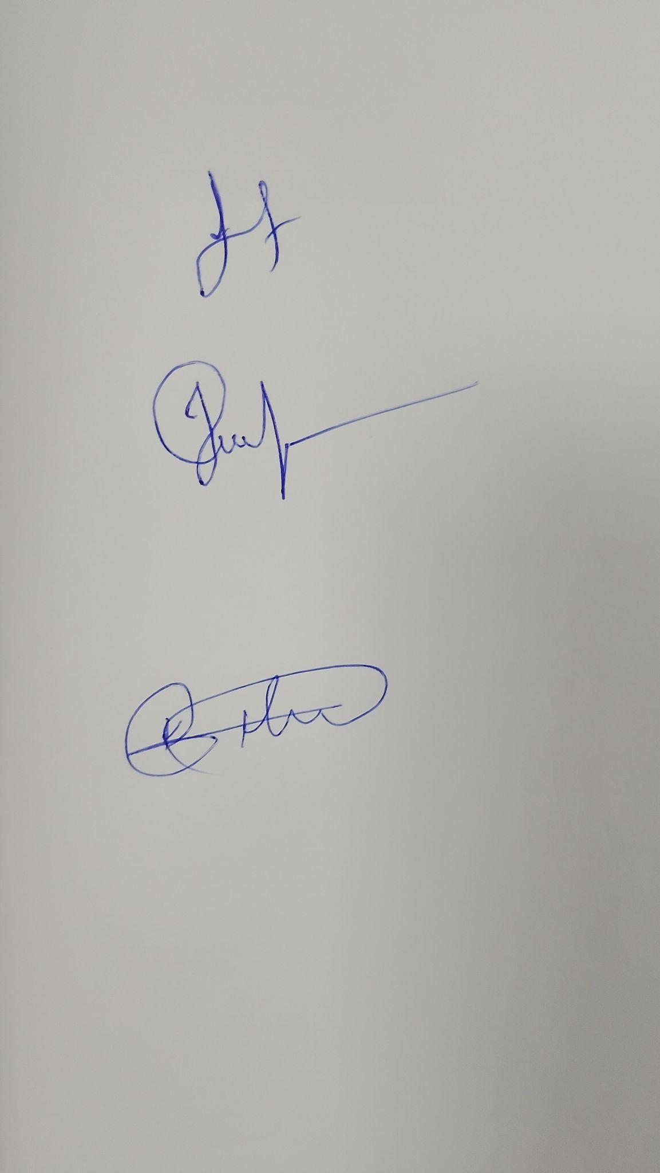
SANKARAN A, JAYAPRAKASH V, KIRUTHIK A, KAVINTIMO
Contact Details:
Phone: 8838928817
Email: sankaranpec@gmail.com

